In the realm of statistical modeling and data analysis, Ridge Regression and Partial Least Squares (PLS) regression stand as pivotal techniques, each offering unique insights and handling of data, particularly in scenarios where predictors are highly correlated. This essay delves into an application of these methods to predict song popularity using a large dataset, examining the differences in how these models treat predictors like bitrate, favorites count, and play count. Furthermore, it explores the practical challenges encountered during the analysis, including the handling of package conflicts in R, and provides a detailed interpretation of the results obtained from these models.

**1. Data Preparation and Challenges**

The analysis began with loading a large song dataset, renamed simply as "data" for convenience. This dataset included various features relevant to song popularity, such as bitrate, favorites count, play count, and a popularity index, which served as the response variable. The primary challenge encountered early on was a conflict between the dplyr and MASS packages in R, specifically related to the select() function. Both packages provide this function, but with differing implementations, leading to a "masking" issue when both were loaded simultaneously. This problem is common in R and can be resolved by either explicitly specifying the package when calling the function (e.g., dplyr::select()) or by careful management of the order in which packages are loaded.

Another challenge involved handling missing data. In any large dataset, missing values are inevitable and can significantly impact the reliability of the model. The use of the na.omit() function in R was crucial in removing incomplete cases, thereby ensuring the integrity of the subsequent analyses. This step was particularly important given the high dimensionality and potential multicollinearity in the data, where even small inconsistencies could lead to misleading results.

**2. Ridge Regression and Partial Least Squares (PLS) Regression**

Ridge Regression and PLS were chosen for this analysis due to their ability to handle multicollinearity, a common issue in datasets with numerous predictors. Ridge Regression introduces a penalty term to the standard linear regression model, which shrinks the coefficients and mitigates the impact of collinear predictors. PLS, on the other hand, combines features of principal component analysis and multiple linear regression, extracting components that maximize the covariance between the predictors and the response variable.

In this analysis, Ridge Regression and PLS were applied to the predictors bitrate, favorites count, and play count, with the goal of predicting the popularity index. The coefficients obtained from these models were normalized for comparison, providing a clear view of how each model assigns importance to the predictors.

**3. Interpretation of Results**

The normalized coefficients from Ridge Regression and PLS presented stark contrasts in their interpretation of the data:

* **Bitrate**: Ridge Regression assigned a moderately positive coefficient (0.386), indicating that higher bitrate is associated with a higher popularity index. PLS, however, assigned a near-zero coefficient (-0.003), suggesting that bitrate is not a significant predictor in the PLS model.
* **Favorites Count**: This predictor showed a significant difference between the models, with Ridge Regression assigning a high positive coefficient (0.843), implying a strong positive relationship with the popularity index. In contrast, PLS assigned a much lower coefficient (0.025), downplaying its importance.
* **Play Count**: Perhaps the most striking difference was seen with play count. Ridge Regression assigned a moderate positive coefficient (0.374), while PLS assigned a strong negative coefficient (-0.999), indicating a substantial negative relationship. This divergence suggests that the two models view the role of play count in predicting popularity very differently.

These differences highlight the fundamental distinctions between the models. Ridge Regression tends to retain all predictors, albeit with shrunk coefficients, thus providing a more conservative estimate of predictor importance. PLS, on the other hand, focuses on components that explain the most variance, which can result in the exclusion or downplaying of predictors that do not contribute significantly to this variance.

**4. Visualizing the Results**

To better understand the results, several visualizations were created. Bar plots and histograms were used to compare the normalized coefficients from both models, with custom color palettes applied to enhance clarity. The bar plot clearly illustrated the differences in how each model weighed the predictors, while the histograms provided a distributional overview of the coefficients.

Additionally, a scatter plot was created to examine the relationship between the normalized coefficients from Ridge Regression and PLS. The inclusion of a regression line in the scatter plot helped to identify any underlying trends between the two sets of coefficients. This visualization revealed that while some predictors (like favorites count) had coefficients that aligned closely across models, others (like play count) showed significant divergence.

**5. Conclusion**

The application of Ridge Regression and PLS to the song popularity dataset provides valuable insights into how different statistical models handle multicollinearity and predictor importance. While Ridge Regression offers a more conservative approach by retaining all predictors with shrunk coefficients, PLS emphasizes those predictors that contribute most to the response variable's variance. The visualizations further enhance our understanding of these differences, offering a clear, graphical representation of how each model interprets the data.

This analysis also underscores the importance of careful data preparation and package management in R, particularly when dealing with large, complex datasets. The challenges encountered and the solutions implemented provide a practical guide for similar analyses in the future.

In summary, the choice between Ridge Regression and PLS should be guided by the specific goals of the analysis. If retaining all predictors is important, Ridge Regression may be preferred. However, if the focus is on identifying the most influential predictors, PLS might offer more valuable insights. The interpretations drawn from this analysis can serve as a foundation for further exploration into the modeling of song popularity or similar predictive tasks.

```````````````

I believe that early I installed the ‘dplyr’ package without restarting R Studio that cause an error when I attempted to load the “MASS” package, which would allow myself to support statistical analysis for fitting linear and generalized linear models, that includes a large variety statistical techniques including functions to handle robust regression and discriminant analysis more however I ran into a warning message. The message indicated that the function ‘select()’ from the ‘dplyr’ packages is being “masked” by another package, mostly likely the ‘MASS’ package. I believe both of the packages have the same function named ‘select’ and when I load both packages in R Studio causes confusion on which version of the function to utilize by default. For example when I loaded the ‘MASS’ package after the ‘dplyr’ packages and the ‘selec()’ function from the ‘MASS’ simply overrides the one from the ‘dplyr’ package in the search path when I am loading the dataset.

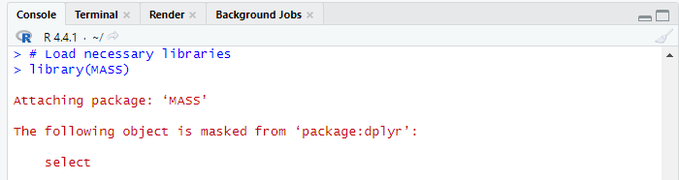

Then I tried to install the “pls” package in R Studio so it could provide the essential tools necessary for my Partial Least Squares (PLS) regression. That will allow myself to apply specific techniques that would combine elements of principal component analysis and multiple linear regression to handle my complex high-dimensional dataset called “large_song_dataset” which I renamed simply “data” with multicollinearity. To further my analysis of the key functions included in the plsr() for fitting PLS models and pcr() for Partial Least Squares Discriminant Analysis (PLS-DA) that will allow better predictive modeling and classifications amongst my predictors. Because the package can support model validation with cross-validation tools and offers visualization capabilities to interpret my results. I took these precautions to help in my research as I was a little nervous when working with my complex dataset because typically standard regression methods might not work well because I choose to have multiple predictors that are highly related to each other.

Actually that was not the issue, I made a mistake and did not include quotation marks properly to locate the package after doing some research.

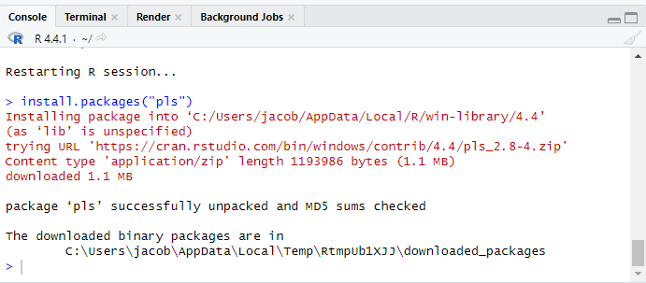

Now lets inspect the data with the head function:

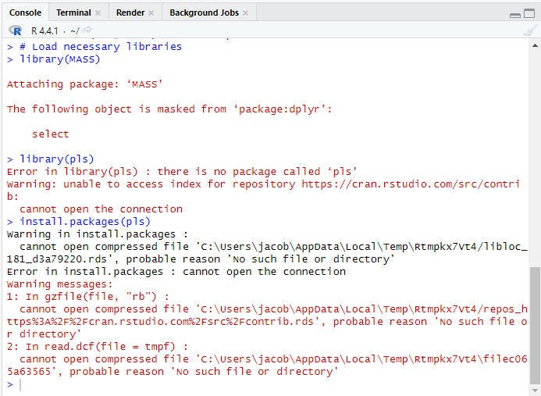

Next, I will start the preparation phase for getting the data ready for modeling because some of the variables are categorical or text that will disrupt my statistical analysis. In order for it work properly I need to select the most relevant numerical variables for my ridge regression and PLS and my top considerations are “bitrate, favorites_count, popularity_index, and play_count as predictors, and popularity_index as the response variable.”

I will start by checking for missing values.

Part of my data preparation phase, I decided to utilize the “na.omit()” function, in order to remove rows from my data matrix that could cause harm to my model. This function allows myself to locate and remove missing values (NAs) by applying this function to any row with one or more NA values from my dataset so in the future it will not affect my subsequent analyses or models by incomplete data. This will maintain the integrity of statistical analysis results by making sure that only complete cases are considered for better accuracy.

Ridge regression and PLS comparisons and results:

**Interpretation**

Interpretation of the differences in the normalized estimates reflects how the underlying methods’ brings everything in a clearly focus. You see the ridge regression shrinks all coefficients but at the same time retains them. Then the PLS extracts the components that can change the relative importance of predictors based on their covariance with their responses. When Normalization of the Estimates, I noticed that the estimates from the PLS and ridge regression have both been normalized, or scaled to have a Euclidean norm of 1. This makes it possible to compare their relative positions and dimensions simultaneously.

Bitrate:  
  
Ridge normalized: 0.3861142.  
PLS Normalized: -0.003158576.  
Interpretation:

The ridge regression estimate for bitrate is roughly 0.386, but the PLS value is nearly nil. This suggests that bitrate has a moderately favorable influence on the response (popularity_index) in the ridge regression model, but has no effect in the PLS. This contrast shows that ridge regression considers bitrate to be important for predicting popularity_index, whereas PLS does not.

Favorites Count:  
  
Ridge normalized: 0.8430689.  
PLS normalized: 0.025057827.  
Interpretation:

The ridge regression estimate for favorites_count is significantly bigger (0.843) than the PLS estimate (0.025). This suggests that ridge regression sees favorites_count as a strong predictor of popularity_index, whereas PLS gives it a considerably lower weight, hinting that it may not be as influential in the PLS model.

Play Count:

Ridge Normalized: 0.3743670

PS Normalized: -0.999681013   
Interpretation:

The ridge regression estimate for play_count is approximately 0.374, implying a slight positive influence. Nevertheless, the PLS estimation is about -1.000, indicating a significant negative influence. This significant difference suggests that ridge regression and PLS models have distinct viewpoints on the impact of play_count. PLS may have revealed a strong negative link between play_count and popularity_index, whereas ridge regression yields a more moderately positive result.

**Summary**

* **Ridge Regression:** Tends to produce coefficients that are generally smaller in magnitude and include regularization to prevent overfitting. It gives weight to all predictors but shrinks their magnitude.
* **PLS:** Focuses on extracting components that maximize the covariance between predictors and response. PLS might zero out or give small weights to some predictors if they don't contribute significantly to the covariance structure.